SETIKA MUNJAL

2301410029

BTECH CSE CYBER SECURITY

ASSIGNMENT – 1

Task 1: Process Creation Utility

Write a Python program that creates N child processes using os.fork(). Each child prints:

- Its PID

- Its Parent PID

- A custom message

The parent should wait for all children using os.wait().

CODE:

OUTPUT:

Task 2: Command Execution Using exec()

Modify Task 1 so that each child process executes a Linux command (ls, date, ps, etc.) using os.execvp() or subprocess.run().

CODE:

OUTPUT:

Task 3: Zombie & Orphan Processes

Zombie: Fork a child and skip wait() in the parent.

Orphan: Parent exits before the child finishes.

Use ps -el | grep defunct to identify zombies.

CODE:

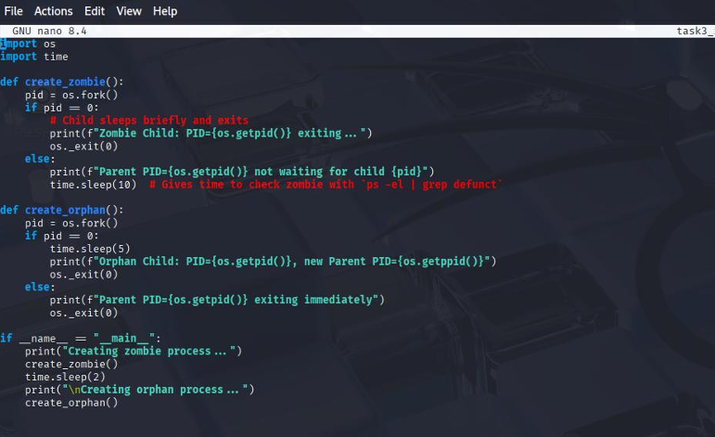

OUTPUT:

Task 4: Inspecting Process Info from /proc

Take a PID as input. Read and print:

- Process name, state, memory usage from /proc/[pid]/status

- Executable path from /proc/[pid]/exe

- Open file descriptors from /proc/[pid]/fd

CODE:

OUTPUT:

Task 5: Process Prioritization

Create multiple CPU-intensive child processes. Assign different nice() values. Observe and log execution order to show scheduler impact.

OUTPUT:  
